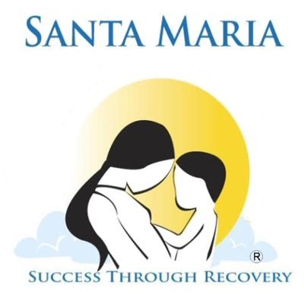

For More Information
Janet Deleon
jdeleon@santamariahostel.org
832-875 9628
www.santamariahostel.org

Santa Maria Luncheon Celebrates Another Year of Helping Women Rise in Recovery
“Raising Over $155K to fund programs for women and their children”
For Immediate Release, Houston TX May, 22 2019
Santa Maria held its 4th annual Rise luncheon at the River Oaks Country Club on Tuesday, April 30th. The organization assists women and families impacted by addiction, incarceration, homelessness and other trauma. Over 300 supporters gathered to commemorate the impact being made in the community, and to honor those who contribute to fulfill this mission.
Reverend Dr. Matthew Russell was honored with the Visionary award, in recognition of two decades of work giving voice to and building welcoming communities for individuals in recovery and others who have been marginalized. “Houston is a city that supports recovery, and at the heart of it is Santa Maria. What we are all doing here today is bringing hope in the midst of despair,-certainly there is a strong network of recovery that is vital in our city,” he stated.
The Rise community awards were presented independently to Kirksey Architecture and D.E. Harvey Builders for their community outreach efforts and their role as key contributors to a major renovation project involving hundreds of hours of labor and volunteers at the Santa Maria Jacquelyn facility located in Spring Branch. The project, which included various companies in the construction and design industry, was made possible through the national Association of Engineers and Contractors who Care project (AEC-Cares). The women served at the facility are now able to enjoy a remodeled cafeteria, group rooms and playground for their children.
Catherine Callaway, architect and senior associate received the award on behalf of Kirksey, and Matt Weber, Superintendent received the award on behalf of Harvey Builders. “One of the things that is most satisfying as a builder is to work on construction that benefits people, and this has been one of the most rewarding projects for us,” stated Weber.
Santa Maria alumni Sharon Hadley and Courtney Mendoza shared their journey in recovery, going from being hopeless and frightened consumed by addiction, to the transformed women, mothers and recovery advocates they are today. They extended their gratitude to the audience for contributing financially and in many other ways to Santa Maria.
Each attendee walked away with a gift bag provided by the presenting sponsor, Palais Royal, part of the Stage family. “Our associates have willingly given a portion of their pay to benefit Santa Maria, and it makes me feel so proud to see the impact we are making, ” shared Amy Gray, EVP Human Resources Officer for Stage. In addition to contributing financially, Stage employees visit Santa Maria regularly to do interactive activities with the clients, such as arts and crafts and cooking classes.

Santa Maria CEO, Nadine Scamp shared highlights from the past year and expressed her gratitude for all those in attendance. “Thank you for being part of the recovery movement and for your support in helping our families rise up and reclaim their hope and their purpose,” she stated.

“The community has really stepped up, and we are changing lives. There is unconditional love and there is nothing better than the community helping each other, and women helping women,” stated Board Chair, Kelli Fondren, thanking guests for their contributions and encouraging everyone to continue supporting the mission.
About Santa Maria
Santa Maria serves over 5,000 individuals annually.
Mission: To empower women and their families to lead healthy, successful, productive and self-fulfilling lives.
Santa Maria is one of Texas’ largest multi-site residential and outpatient treatment centers for women, and one of the only programs in the State where a mother can bring her children with her while she accesses treatment . We provide a full continuum of services to meet each woman or family where they are on their recovery journey. Our services range from community-based prevention and intervention programs, to long term recovery support, housing and aftercare.
By offering vital services and life changing support, Santa Maria provides a pathway to success through recovery. From recovery from addiction, homelessness, incarceration, abuse and other trauma, we have the experience and compassion to help women rise, transform their lives and heal families.
2019 RISE Luncheon Sponsors
Palais Royal, www.stage.com
MAREK
Center Point Energy, www.centerpointenergy.com
John P. McGovern Foundation
Sylvia Barnes and Jim Trimble
Kelli Fondren and Elizabeth Hurst
Houston Methodist, www.houstonmethodist.org
3i International, www.3i-intl.com
Andrew and Maylynn Icken Foundation
Community Health Choice, www.communityhealthchoice.org
Deborah Keyser and Frank Rynd
Legacy Community Health, www.legacycommunityhealth.org
Elizabeth Perez
Keith Rudy and Insperity
University of Houston Downtown, www.uhd.edu

www.santamariahostel.org
######

